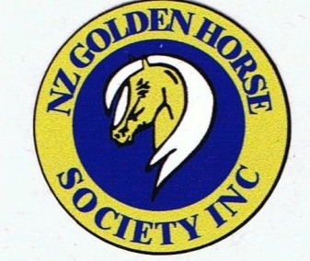
A Registration Society
Please return form to:
Registrations Officer
Sharon Stevens
668 Mountain Road
RD3
New Plymouth
nzgoldenhorsesociety@gmail.com

For Palomino,Buckskin
CremelloandPerlinos
*Paints,*appaloosas,
(*based on Palomino, Buckskin
Cremello or Perlino colour base)

CHANGE OF OWNERSHIP FORM

Cost: $10 CHEQUES PAYABLE TO: N.Z. Golden Horse Society Inc.
Account number for internet payments: BNZ – 02 0324 0081871 00

Please send back your original Certificate to registrations officer.

Previous Owners full name: …………………………………………………………………….
Address: …………………………………………………………………….
…………………………………………………………………….
…………………………………………………………………….

Phone:.......................... Email .................................................

Name of Horse/Pony: …………………………………………………………………….

Registration Number: ………………………

New Owners details
Sold to: …………………………………………………………………….
Address: …………………………………………………………………….
…………………………………………………………………….
…………………………………………………………………….

Phone....................................................................................

Email......................................................................................

Signature of Seller: …………………………………..

Date: ……………………

For Office Use Only
Reg No:…………………………………….. Date:…………………………………… Receipt:……………………………….

